Mission
Enabling Combat capabilities through steadfast Financial Services, Financial Analysis and sound Decision Support.
Vision
Qualified professionals ready for an ever evolving financial and contingency environment.
Priorities
Mission: Set High Standards – Leave the 82d TRW better than you found it
People: Uphold Mutual Respect, Inclusivity, & Professionalism
Processes: Think Smarter, Leverage Innovation, and Create Partnerships
Commander/Comptroller:
Major Nathan Schaick
DSN: 312-736-6114
SEL:
SMSgt Travis Muller
DSN: 312-736-4879
First Sergeant:
TSgt Raul Garcia DSN: 312-736-2998
Contact Info
Building 402 – 1st Floor, Room
In-Person Customer Service Hours:
Monday, Tuesday, Thursday: 0900-1600
Wednesday, Friday: 0900-1300
Org Box Email Address:
finance.customerservice@us.af.mil
Customer Service Link:
https://csp.cce.af.mil/#/
**These hours exclude all Federal Holidays, Wing Down Days, and Resiliency Days. We will also be closed for training every 3rd Wednesday of the month.**
ICE Comments
The 82d Comptroller Squadron would like to hear your compliments, suggestions and concerns so we can better serve YOU!


Scan the QR Code above… let us know how we can better serve you!
82d Comptroller Squadron Information Guide
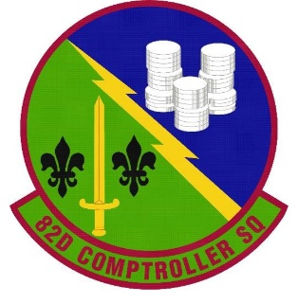


Flight Commander
2d Lt John Curcio
John.curcio.3@us.af.mil
Flight Chief
MSgt Crystol Cotton
Crystol.cotton@us.af.mil
Finance Queue System


Sheppard AB Entitlement Handout

Trouble Viewing your LES?
The following website will help you to understand your LES:
http://www.dfas.mil/airforce2/militarypay/yourleaveearningsstatementles.html
GTC questions?
The below QR code will enable you to view your GTC statement and pay your bill.
NOTE! 30 days from your bill due date you are considered delinquent. It is your responsibility to pay your card.

QR Code to Citibank Login
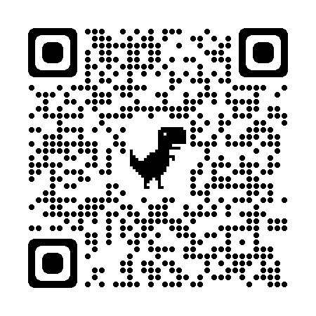
MYPAY?
- You can start, stop, or change allotments
- View your LES
- Update your Direct Deposit
- View your TSP/TAX information
- Update your address https://mypay.dfas.mil
- View SDP Statements

When will my Travel Voucher pay out? Generally, travel vouchers can take up to three weeks to fully pay by the Air Force Financial Services Center. If your voucher is returned for corrections, you will be notified to come into the Finance Office for corrections.

What about my Military Pay?
Please submit Military Pay Effecting documents in person during our customer service hours or by using the Comptroller Services Portal (CSP). You must be on a CAC enabled device to utilize the CSP website.

What entitlements and deductions can I expect in the Air Force?

IMMINENT DANGER PAY (IDP) – IDP is $225.00 per month (pro-rated; $7.50 daily rate) If you leave your IDP location for any reason (i.e. leave, TDY, etc.) your entitlement will be deducted from you upon return. It is only payable while at that IDP location.

HARDSHIP DUTY PAY (HDP) – HDP varies from $50, $100, or $150 per month depending on location. All members serving on PCS in a designated area or serving in a temporary duty or deployed status for over 30 consecutive days in the area will receive HDP. Entitlement to HDP continues through the PCS departure date.
COMBAT ZONE TAX EXEMPTION (CZTE) - Federal and State taxes will be turned off while at excluded zones.

FAMILY SEPARATION – $300.00 per month (pro-rated; $10 daily rate). Starts when you depart Old PDS. Members with dependent(s) only.

MEAL DEDUCTIONS – (E-4 and below) The deduction rate is: $405.00 (pro-rated; $11.60 daily rate). If you are in a leave status/TDY, you will not have meal deductions for that period.

TEMPORARY LODGING EXPENSE (TLE) – Reimburses service members for lodging/meals during a CONUS PCS move, covering costs for up to 10-21 days (depending on move type) at the old or new duty station, before HHG arrives, or while house hunting, offsetting per diem costs with receipts required, capped daily at $290, and calculated based on family size and location's per diem rates.

SAVINGS DEPOSIT PROGRAM (SDP) – SDP is a savings program for military members stationed in a Combat Zone. To qualify, you must be on station for 30 days to start allotment, and 60 days to make a cash/check deposit. To start SDP, you must physically come into Finance to initiate the process once eligible. Interest is 10% annually, 2.5% compounded quarterly. You cannot deposit more than your monthly income (take home pay after all deductions, allotments, TSP, etc). You CANNOT start the allotment in MyPay. The maximum amount for accruing interest is $10,000. Every deposit must be in increments of $5.

